Assignment 5

1) Write a query that will give you all orders for more than Rs. 1,000.
Ans:-

SELECT * FROM ORDERS WHERE Amt > 1000;

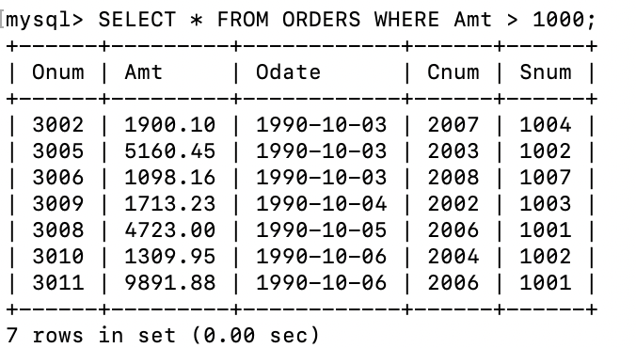

2) Write a query that will give you the names and cities of all salespeople in London with a commission above. 10.

SELECT Sname,City FROM SALESPEOPLE WHERE City = "London" and Comm > 0.10;

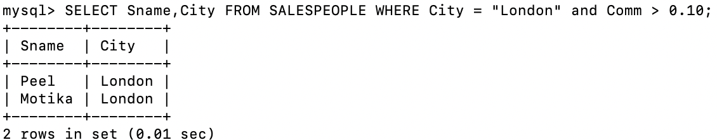

3) Write a query on the Customers table whose output will exclude all customers with a rating <= 100, unless they are located in Rome.

SELECT * FROM CUSTOMERS WHERE Rating>100 OR City ="Rome";
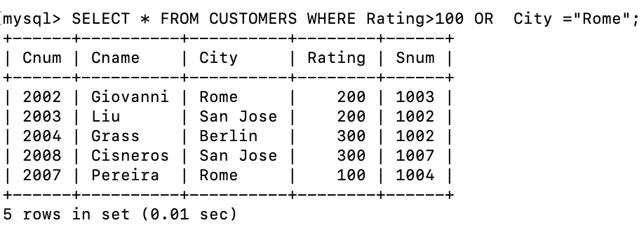

4) What will be the output from the following query?

Select * from Orders
where (amt < 1000 OR
NOT (odate = '1990-10-03' AND cnum > 2003));

Ans:-
The amount is less than 1000 with the order date should not be 1990-10-03 and the customer number should not be greater than 2003 .

5) What will be the output of the following query?
Select * from Orders where NOT ((odate = '1990-10-03' OR snum >1006) AND amt >= 1500);

Ans:-
The order date should not be 1990-10-03 with snum should not be greater than 1006 and amount is greater than equal to 1500.

6) What is a simpler way to write this query?
Select snum, sname, city, comm From Salespeople
where (comm >.12 OR comm <.14);

Ams:-
SELECT snum, sname, city, comm FROM Salespeople
WHERE comm BETWEEN 0.12 AND 0.14;

